Ví dụ chi tiết — Full walkthrough từng method

Setup chung (dùng nhất quán cho tất cả)

Câu: "I found the food delicious but service was terrible"
Aspect: "food" — sentiment: positive, category: FOOD

Tokenization SPC (13 valid tokens + padding đến 128):

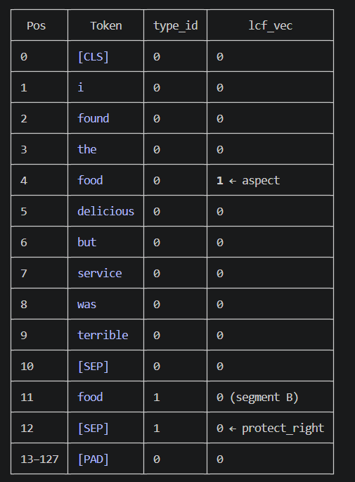
BERT hidden states (4D toy vectors):
Ví dụ:
v0 = [1, 0, 1, 0] [CLS]
v1 = [1, 1, 0, 1] i
v2 = [2, 1, 2, 1] found
v3 = [1, 0, 1, 1] the
v4 = [5, 4, 3, 2] food ← aspect
v5 = [4, 3, 2, 2] delicious
v6 = [1, 0, 2, 0] but
v7 = [3, 2, 1, 2] service
v8 = [1, 1, 2, 0] was
v9 = [3, 1, 0, 3] terrible
v10 = [1, 0, 2, 1] [SEP_mid]
v11 = [5, 4, 3, 2] food_B (= v4, same token)
v12 = [0, 1, 0, 1] [SEP_end]

---
1 — LCF‑CDW: Context Dynamic Weight

File: dataset_utils.py:95 + fast_lcf_bert_multitask.py:41

Công thức:
center = (a_start + a_end) / 2 = (4 + 4) / 2 = 4.0
half_aspect = floor((4 - 4 + 1) / 2) = floor(0.5) = 0

SRD_i = max(0, |i - 4.0| - 0) = |i - 4|

w_i = 1.0 nếu SRD_i ≤ α = 5
= (L - (SRD_i - α)) / L nếu SRD_i > α [L = 128]

Bảng CDW cho toàn bộ 128 positions:

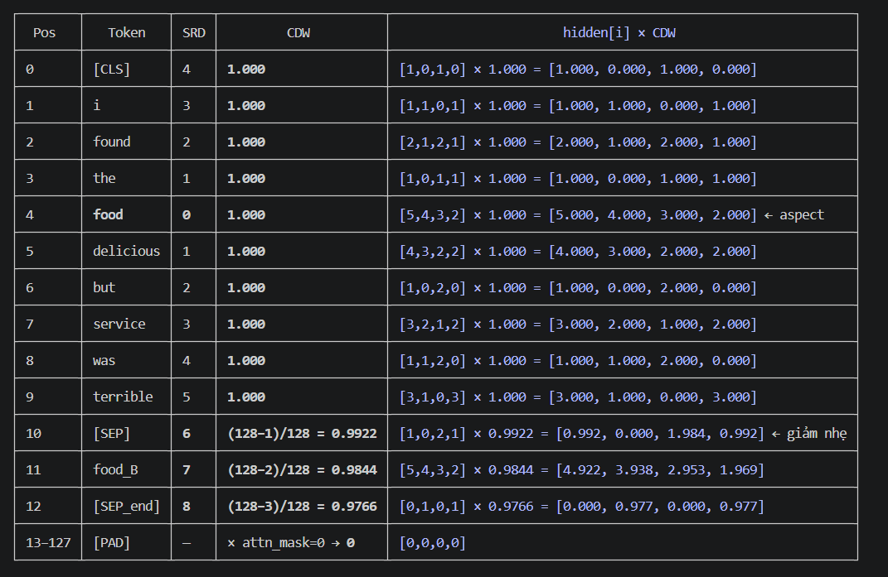 Kết quả lcf_features (CDW):
lcf_features = hidden × cdw.unsqueeze(-1)
# shape: (13 valid rows + 115 zero rows, 4)

# Tất cả valid token GIỮ signal
# Chỉ 3 token cuối (pos 10,11,12) bị giảm nhẹ (0.99–0.98)
# PAD: 0 do attention_mask=0

▎ Với câu dài hơn: Record "You serve is very professional...staff." (~23 valid tokens, aspect tại pos 1–2): tokens từ pos 8 đến pos 22 có SRD từ 5.5 đến 19.5 → CDW từ 0.996
▎ xuống 0.887. CDW giảm mượt — token xa vẫn đóng góp, chỉ ít hơn.

---
2 — LCF‑CDM: Context Dynamic Mask

File: fast_lcf_bert_multitask.py:82

Công thức: Giống CDW nhưng binary — không có gradient:
w_i = 1.0 nếu SRD_i ≤ α = 5
= 0.0 nếu SRD_i > α ← cắt cứng, không phụ thuộc L

Bảng CDM:

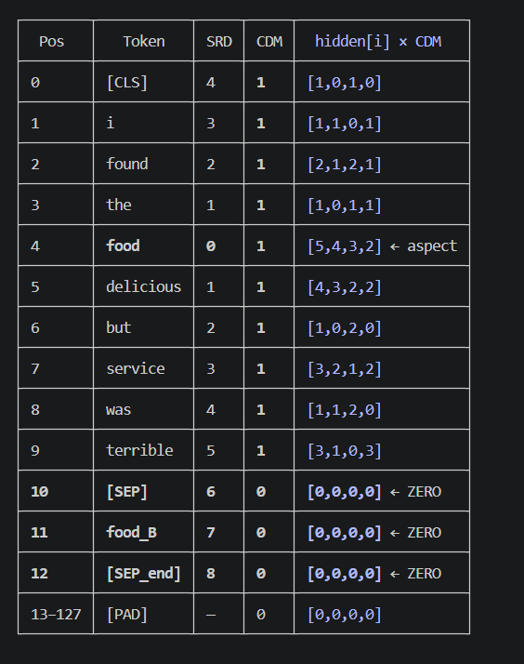

So sánh trực tiếp CDW vs CDM tại pos 10–12:

CDW result CDM result
pos10 [SEP]: [0.992, 0.000, 1.984, 0.992] vs [0.000, 0.000, 0.000, 0.000]
pos11 food_B: [4.922, 3.938, 2.953, 1.969] vs [0.000, 0.000, 0.000, 0.000]
pos12 [SEP]: [0.000, 0.977, 0.000, 0.977] vs [0.000, 0.000, 0.000, 0.000]

Với câu gốc dataset (23 valid, aspect pos 1–2):

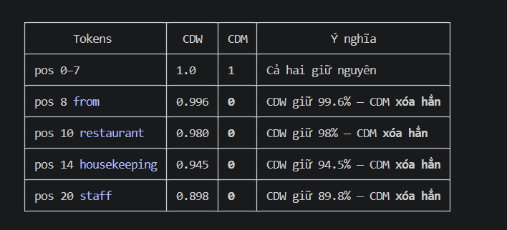

▎ Câu ngắn (13 tokens): chênh lệch nhỏ (3 tokens cuối). Câu dài: CDM cắt 15+ tokens — local stream chỉ còn "I found the food delicious but service was terrible" bỏ
▎ SEP/segment-B. CDW thì giữ tất cả với trọng số giảm dần.

---
3 — ToMe Bipartite (_bipartite_pairs, line 49)

Chuẩn bị:
x_seg (13 valid tokens, 4D)
lcf_seg = [0,0,0,0,1,0,0,0,0,0,0,0,0]
protect_left=1, protect_right=1, aspect_mask pos4=True

Interior pool (loại CLS, [SEP_end], aspect):
inner[:1] = 0 # CLS (pos 0)
inner[-1:] = 0 # SEP_end (pos 12)
inner *= ~aspect_mask # food (pos 4) position

pos = [1, 2, 3, 5, 6, 7, 8, 9, 10, 11] # 10 tokens

Bipartite split (xen kẽ theo index trong pool):
index trong pool: 0 1 2 3 4 5 6 7 8 9
token gốc pos: 1 2 3 5 6 7 8 9 10 11
group: A B A B A B A B A B

Group A: pos [1(i), 3(the), 5(delicious), 7(service), 9(terrible)]
Group B: pos [2(found), 6(but), 8(was), 10([SEP]), 11(food_B)]

Normalize vectors:

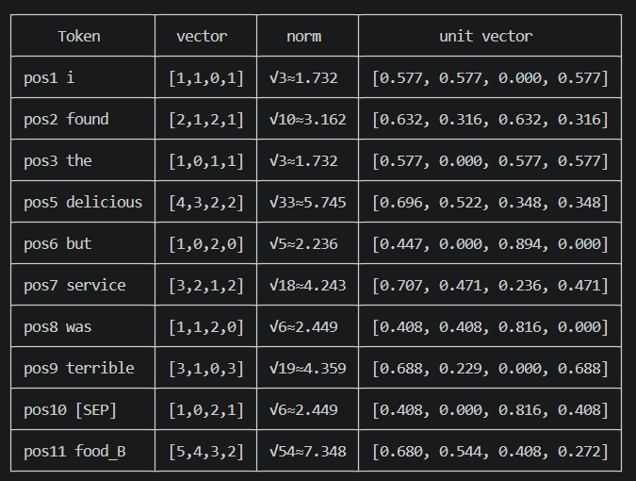

Score matrix A × B (dot product của unit vectors):

B[0]=pos2 B[1]=pos6 B[2]=pos8 B[3]=pos10 B[4]=pos11
(found) (but) (was) ([SEP]) (food_B)

A[0]=pos1(i)
0.577×0.632 0.577×0.447 0.577×0.408 0.577×0.408 0.577×0.680
+0.577×0.316 +0.577×0 +0.577×0.408 +0.577×0 +0.577×0.544
+0 ×0.632 +0 ×0.894 +0 ×0.816 +0 ×0.816 +0 ×0.408
+0.577×0.316 +0.577×0 +0.577×0 +0.577×0.408 +0.577×0.272
= 0.729 0.258 0.470 0.470 0.863

A[1]=pos3(the)
0.577×0.632 0.577×0.447 0.577×0.408 0.577×0.408 0.577×0.680
+0 ×0.316 +0 ×0 +0 ×0.408 +0 ×0 +0 ×0.544
+0.577×0.632 +0.577×0.894 +0.577×0.816 +0.577×0.816 +0.577×0.408
+0.577×0.316 +0.577×0 +0.577×0 +0.577×0.408 +0.577×0.272
= 0.912 0.774 0.706 0.941 0.783

A[2]=pos5(delicious)
0.696×0.632 0.696×0.447 0.696×0.408 0.696×0.408 0.696×0.680
+0.522×0.316 +0.522×0 +0.522×0.408 +0.522×0 +0.522×0.544
+0.348×0.632 +0.348×0.894 +0.348×0.816 +0.348×0.816 +0.348×0.408
+0.348×0.316 +0.348×0 +0.348×0 +0.348×0.408 +0.348×0.272
= 0.935 0.622 0.781 0.710 0.994 ← MAX

A[3]=pos7(service)
0.707×0.632 0.707×0.447 0.707×0.408 0.707×0.408 0.707×0.680
+0.471×0.316 +0.471×0 +0.471×0.408 +0.471×0 +0.471×0.544
+0.236×0.632 +0.236×0.894 +0.236×0.816 +0.236×0.816 +0.236×0.408
+0.471×0.316 +0.471×0 +0.471×0 +0.471×0.408 +0.471×0.272
= 0.894 0.527 0.674 0.674 0.961

A[4]=pos9(terrible)
0.688×0.632 0.688×0.447 0.688×0.408 0.688×0.408 0.688×0.680
+0.229×0.316 +0.229×0 +0.229×0.408 +0.229×0 +0.229×0.544
+0 ×0.632 +0 ×0.894 +0 ×0.816 +0 ×0.816 +0 ×0.408
+0.688×0.316 +0.688×0 +0.688×0 +0.688×0.408 +0.688×0.272
= 0.724 0.308 0.374 0.562 0.780

Greedy assignment (argmax mỗi hàng):
A[0]=pos1(i) → argmax = B[4]=pos11(food_B) sim=0.863
A[1]=pos3(the) → argmax = B[3]=pos10([SEP]) sim=0.941
A[2]=pos5(delicious) → argmax = B[4]=pos11(food_B) sim=0.994 ← CONFLICT
A[3]=pos7(service) → argmax = B[4]=pos11(food_B) sim=0.961 ← CONFLICT
A[4]=pos9(terrible) → argmax = B[4]=pos11(food_B) sim=0.780 ← CONFLICT

Dedup (B chỉ dùng 1 lần):
used_B = set()
ia=0 (pos1): ib=4 not in used → pair(pos1→pos11) ✓ used_B={4}
ia=1 (pos3): ib=3 not in used → pair(pos3→pos10) ✓ used_B={4,3}
ia=2 (pos5): ib=4 IN used_B → SKIP
ia=3 (pos7): ib=4 IN used_B → SKIP
ia=4 (pos9): ib=4 IN used_B → SKIP

2 cặp merge — áp dụng _merge_pairs (line 172):

# Pair 1: src=pos1(i), dst=pos11(food_B)
x_new[pos1] = 0.5 * (v1 + v11)
= 0.5 * ([1,1,0,1] + [5,4,3,2])
= 0.5 * [6, 5, 3, 3]
= [3.0, 2.5, 1.5, 1.5]
lcf[pos1] = max(0, 0) = 0

# Pair 2: src=pos3(the), dst=pos10([SEP_mid])
x_new[pos3] = 0.5 * (v3 + v10)
= 0.5 * ([1,0,1,1] + [1,0,2,1])
= 0.5 * [2, 0, 3, 2]
= [1.0, 0.0, 1.5, 1.0]
lcf[pos3] = max(0, 0) = 0

keep = [T, T, T, T, T, T, T, T, T, T, F, T, F]
# ↑pos10 ↑pos11 removed

Sau Step 1: 13 → 11 tokens (re-indexed):

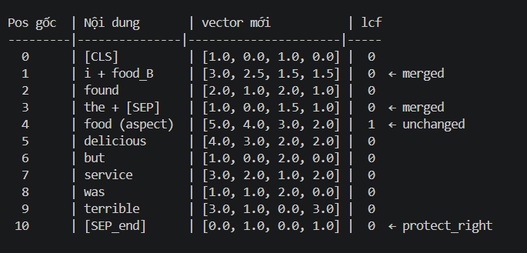

Step 2 trên 11 tokens (re-index 0–10):

protect_left=1 (pos0), protect_right=1 (pos10), aspect lcf[3]=1
Interior pool (trừ pos0, pos10, pos3_aspect):
pos = [1, 2, 4, 5, 6, 7, 8, 9] (8 tokens)

Group A (even): pos[0]=1(i+food_B), pos[2]=4(delicious), pos[4]=6(but), pos[6]=8(terrible)
Group B (odd): pos[1]=2(found), pos[3]=5(service), pos[5]=7(was)

Score matrix A×B (tính tương tự, key results):

B[0]=pos2(found) B[1]=pos5(service) B[2]=pos7(was)

A[0]=pos1(i+food_B) [3,2.5,1.5,1.5] |v|=√23.75≈4.873
n1=[0.616,0.513,0.308,0.308]
B[0]: 0.616×0.632+0.513×0.316+0.308×0.632+0.308×0.316 = 0.389+0.162+0.195+0.097 = 0.843
B[1]: 0.616×0.707+0.513×0.471+0.308×0.236+0.308×0.471 = 0.435+0.242+0.073+0.145 = 0.895
B[2]: 0.616×0.408+0.513×0.408+0.308×0.816+0.308×0.000 = 0.251+0.209+0.251+0.000 = 0.711

A[1]=pos4(delicious) [4,3,2,2] n5=[0.696,0.522,0.348,0.348]
B[0]: 0.935 (tính ở trên)
B[1]: 0.696×0.707+0.522×0.471+0.348×0.236+0.348×0.471 = 0.492+0.246+0.082+0.164 = 0.984 ← MAX
B[2]: 0.696×0.408+0.522×0.408+0.348×0.816+0 = 0.284+0.213+0.284 = 0.781

A[2]=pos6(but) [1,0,2,0] n6=[0.447,0,0.894,0]
B[0]: 0.447×0.632+0+0.894×0.632+0 = 0.283+0.565 = 0.848
B[1]: 0.447×0.707+0+0.894×0.236+0 = 0.316+0.211 = 0.527
B[2]: 0.447×0.408+0+0.894×0.816+0 = 0.182+0.730 = 0.912 ← MAX

A[3]=pos8(terrible) [3,1,0,3] n9=[0.688,0.229,0,0.688]
B[0]: 0.688×0.632+0.229×0.316+0+0.688×0.316 = 0.435+0.072+0+0.218 = 0.725
B[1]: 0.688×0.707+0.229×0.471+0+0.688×0.471 = 0.487+0.108+0+0.324 = 0.919
B[2]: 0.688×0.408+0.229×0.408+0+0.688×0.000 = 0.281+0.093+0 = 0.374

Assignment:
A[0]=pos1 → B[1]=pos5(service) sim=0.895 ✓ used_B={1}
A[1]=pos4 → B[1]=pos5(service) sim=0.984 CONFLICT! B[1] taken
→ SKIP (argmax bị chiếm)
A[2]=pos6 → B[2]=pos7(was) sim=0.912 ✓ used_B={1,2}
A[3]=pos8 → B[1]=pos5(service) sim=0.919 CONFLICT → SKIP

2 cặp:
x_new[pos1] = 0.5 * ([3,2.5,1.5,1.5] + [3,2,1,2])
= 0.5 * [6, 4.5, 2.5, 3.5]
= [3.0, 2.25, 1.25, 1.75]
lc

● x_new[pos6] = 0.5 * ([1,0,2,0] + [1,1,2,0])
= [1.0, 0.5, 2.0, 0.0]
lcf[pos1] = max(0,0)=0, lcf[pos6] = max(0,0)=0
remove pos5(service), pos7(was)

Bipartite kết quả cuối (2 steps): 13 → 11 → 9 tokens

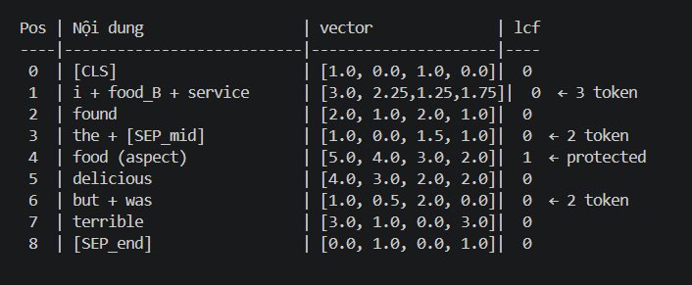
---
4 — ToMe Sequential Local (_sequential_neighbor_merge, line 288)

Khác biệt then chốt so với bipartite: scan trái→phải, mỗi token tự quyết định gập về phía nào. Một token có thể nhận nhiều token cascade vào mình trong 1 pass.

Mid-SEP detection (line 349):
for j in range(1, 12): # protect_left=1, end=12
if lcf[j] < 0.5 and lcf[j+1] > 0.5:
mid_sep[j] = True

# lcf = [0,0,0,0,1,0,0,0,0,0,0,0,0]
# j=3: lcf[3]=0 AND lcf[4]=1 → mid_sep[3] = True ← "the" là boundary

Scan i = 1 → 11 (end=12):

---
i=1 i:
- left=0 [CLS]: has_left=True
- right=2 found: has_right=True

sim_left = cos(v1, v0) = cos([1,1,0,1],[1,0,1,0])
dot = 1+0+0+0 = 1
|v1|=√3≈1.732, |v0|=√2≈1.414
= 1 / (1.732×1.414) = 1/2.449 = 0.408

sim_right = cos(v1, v2) = cos([1,1,0,1],[2,1,2,1])
dot = 2+1+0+1 = 4
|v2|=√10≈3.162
= 4 / (1.732×3.162) = 4/5.477 = 0.730

sim_right(0.730) ≥ sim_left(0.408) → pos2 found gập vào pos1 i
x[1] = 0.5*(v1+v2) = 0.5*([1,1,0,1]+[2,1,2,1]) = [1.5, 1.0, 1.0, 1.0]
lcf[1] = max(0,0) = 0
removed[2] = True
pairs = [(2, 1)]

---
i=2 found: removed=True → skip

---
i=3 the: mid_sep[3]=True → skip

---
i=4 food: aspect_mask=True → skip

---
i=5 delicious:
- left=4 food: has_left=True (aspect CÓ THỂ nhận merge — chỉ không bị xóa)
- right=6 but: has_right=True

sim_left = cos(v5, v4) = cos([4,3,2,2],[5,4,3,2])
dot = 20+12+6+4 = 42
|v5|=√33≈5.745, |v4|=√54≈7.348
= 42 / (5.745×7.348) = 42/42.23 = 0.995

sim_right = cos(v5, v6) = cos([4,3,2,2],[1,0,2,0])
dot = 4+0+4+0 = 8
|v6|=√5≈2.236
= 8 / (5.745×2.236) = 8/12.85 = 0.623

sim_left(0.995) > sim_right(0.623) → pos5 delicious gập vào pos4 food
x[4] = 0.5*(v4+v5) = 0.5*([5,4,3,2]+[4,3,2,2]) = [4.5, 3.5, 2.5, 2.0]
lcf[4] = max(1, 0) = 1 ← aspect signal giữ nguyên!
removed[5] = True
pairs = [(2,1), (5,4)]

---
i=6 but:
- left=5removed→4not removed: has_left=True (pos4, đã có x=[4.5,3.5,2.5,2.0])
- right=7 service: has_right=True

sim_left = cos(v6, x4_updated)
v6=[1,0,2,0], x4=[4.5,3.5,2.5,2.0]
dot = 4.5+0+5.0+0 = 9.5
|v6|=√5≈2.236, |x4|=√(20.25+12.25+6.25+4)=√42.75≈6.539
= 9.5 / (2.236×6.539) = 9.5/14.62 = 0.650

sim_right = cos(v6, v7) = cos([1,0,2,0],[3,2,1,2])
dot = 3+0+2+0 = 5
|v7|=√18≈4.243
= 5 / (2.236×4.243) = 5/9.487 = 0.527

sim_left(0.650) > sim_right(0.527) → pos6 but gập vào pos4 food
x[4] = 0.5*([4.5,3.5,2.5,2.0]+[1,0,2,0]) = [2.75, 1.75, 2.25, 1.0]
lcf[4] = 1
removed[6] = True
pairs = [(2,1),(5,4),(6,4)]

---
i=7 service:
- left=6removed→5removed→4: has_left=True
- right=8 was: has_right=True

sim_left = cos(v7, x4_updated=[2.75,1.75,2.25,1.0])
v7=[3,2,1,2]
dot = 8.25+3.5+2.25+2.0 = 16.0
|v7|=√18≈4.243, |x4|=√(7.5625+3.0625+5.0625+1)=√16.6875≈4.085
= 16.0 / (4.243×4.085) = 16.0/17.33 = 0.923

sim_right = cos(v7, v8) = cos([3,2,1,2],[1,1,2,0])
dot = 3+2+2+0 = 7
|v8|=√6≈2.449
= 7 / (4.243×2.449) = 7/10.39 = 0.674

sim_left(0.923) > sim_right(0.674) → pos7 gập vào pos4
x[4] = 0.5*([2.75,1.75,2.25,1.0]+[3,2,1,2]) = [2.875, 1.875, 1.625, 1.5]
removed[7] = True, pairs = [...,(7,4)]

---
i=8, 9, 10, 11 — tương tự, lần lượt gập vào pos4:

i=8 was: sim_left > sim_right → gập vào pos4
i=9 terrible: sim_left > sim_right → gập vào pos4
i=10 [SEP]: sim_left > sim_right → gập vào pos4
i=11 food_B: has_right=False (right≥end=12), chỉ có left → gập vào pos4

Sequential kết quả (1 pass): 13 → 5 tokens

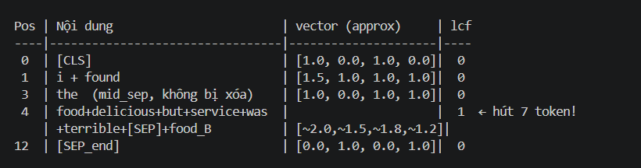

▎ So với bipartite: Bipartite 2 steps → 9 tokens. Sequential 1 pass → 5 tokens. Sequential agressive hơn vì cascade: pos4 nhận liên tiếp 8 token mà không bị giới hạn bởi
▎ num_merge_steps.

---
5 — ToMe Attention Weighted (_attention_weighted_merge, line 196)

Uniform weights (training loop không truyền attention_weights):
attn_seg = torch.ones(13) # tất cả = 1.0
attn_threshold = quantile(attn_seg, 0.75) = 1.0
# is_high_attn: tất cả True — nhưng không được dùng trong candidate_mask!

protected = [T,F,F,F,F,F,F,F,F,F,F,F,T] # pos0 CLS, pos12 SEP_end
is_aspect = [F,F,F,F,T,F,F,F,F,F,F,F,F] # pos4 food

max_merges = (13 - 1 - 1) // 2 = 5

---
Iteration 1:
candidate_mask = ~removed & ~protected & ~is_aspect
= [F,T,T,T,F,T,T,T,T,T,T,T,F]
→ candidates: pos [1,2,3,5,6,7,8,9,10,11]

attn_candidates: non-candidates → inf
argmin: uniform → picks first = pos1(i)
i = 1

Tìm neighbor giống nhất:
neighbor_mask = ~removed & ~is_aspect, pos1=False
→ pos [0,2,3,5,6,7,8,9,10,11,12] hợp lệ

Tính cosine sim từ v1=[1,1,0,1] đến tất cả:
pos0 [CLS] [1,0,1,0]: sim = 1/(√3×√2) = 1/2.449 = 0.408
pos2 found [2,1,2,1]: sim = 4/(√3×√10)= 4/5.477 = 0.730 ← argmax
pos3 the [1,0,1,1]: sim = (1+0+0+1)/(√3×√3) = 2/3 = 0.667
pos5 delicious [4,3,2,2]: sim = (4+3+0+2)/(√3×√33)= 9/9.950= 0.904
pos6 but [1,0,2,0]: sim = (1+0+0+0)/(√3×√5) = 1/3.873= 0.258
pos7 service [3,2,1,2]: sim = (3+2+0+2)/(√3×√18)= 7/7.348= 0.953 ← MAX
pos8 was [1,1,2,0]: sim = (1+1+0+0)/(√3×√6) = 2/4.243= 0.471
pos9 terrible [3,1,0,3]: sim = (3+1+0+3)/(√3×√19)= 7/7.550= 0.927
pos10 [SEP] [1,0,2,1]: sim = (1+0+0+1)/(√3×√6) = 2/4.243= 0.471
pos11 food_B [5,4,3,2]: sim = (5+4+0+2)/(√3×√54)= 11/12.73=0.864
pos12 [SEP_end] [0,1,0,1]: sim = (0+1+0+1)/(√3×√2) = 2/2.449= 0.816

j = 7 (service), sim = 0.953

Merge i=1 vào j=7:
x[7] = 0.5*(v7 + v1) = 0.5*([3,2,1,2]+[1,1,0,1]) = [2.0, 1.5, 0.5, 1.5]
lcf[7] = max(0,0) = 0
removed[1] = True
pairs = [(1, 7)]

---
Iteration 2:
removed=[F,T,F,F,F,F,F,F,F,F,F,F,F]
candidate_mask → pos [2,3,5,6,7,8,9,10,11]
argmin (uniform) → pos2 (i)
i = 2 (found)

neighbor_mask → pos [0,3,5,6,7,8,9,10,11,12] (trừ pos4 aspect, pos2 self)

Sim từ v2=[2,1,2,1]:
pos0 [1,0,1,0]: (2+0+2+0)/(√10×√2) = 4/4.472 = 0.894
pos3 [1,0,1,1]: (2+0+2+1)/(√10×√3) = 5/5.477 = 0.913
pos5 [4,3,2,2]: (8+3+4+2)/(√10×√33)= 17/18.17= 0.935
pos6 [1,0,2,0]: (2+0+4+0)/(√10×√5) = 6/7.071 = 0.849
pos7_updated [2,1.5,0.5,1.5]:
(4+1.5+1+1.5)/(√10×√(4+2.25+0.25+2.25))
= 8/(3.162×2.958) = 8/9.354 = 0.855
pos8 [1,1,2,0]: (2+1+4+0)/(√10×√6) = 7/7.746 = 0.904
pos9 [3,1,0,3]: (6+1+0+3)/(√10×√19)= 10/13.78= 0.726
pos10 [1,0,2,1]: (2+0+4+1)/(√10×√6) = 7/7.746 = 0.904
pos11 [5,4,3,2]: (10+4+6+2)/(√10×√54)= 22/23.24= 0.947 ← MAX
pos12 [0,1,0,1]: (0+1+0+1)/(√10×√2) = 2/4.472 = 0.447

j = 11 (food_B), sim = 0.947

Merge i=2 vào j=11:
x[11] = 0.5*([5,4,3,2]+[2,1,2,1]) = [3.5, 2.5, 2.5, 1.5]
removed[2] = True
pairs = [(1,7),(2,11)]

---
Iteration 3:
candidate_mask → pos [3,5,6,7,8,9,10,11]
i = 3 (the)

Sim từ v3=[1,0,1,1]:
pos5 [4,3,2,2]: (4+0+2+2)/(√3×√33)= 8/9.950= 0.804
pos6 [1,0,2,0]: (1+0+2+0)/(√3×√5) = 3/3.873= 0.775
pos7_upd [2,1.5,0.5,1.5]: (2+0+0.5+1.5)/(√3×2.958)=4/5.124=0.781
pos8 [1,1,2,0]: (1+0+2+0)/(√3×√6) = 3/4.243= 0.707
pos9 [3,1,0,3]: (3+0+0+3)/(√3×√19)= 6/7.550= 0.795
pos10 [1,0,2,1]: (1+0+2+1)/(√3×√6) = 4/4.243= 0.943 ← MAX
pos11_upd [3.5,2.5,2.5,1.5]: (3.5+0+2.5+1.5)/(√3×√24.25)= 7.5/8.596= 0.872
pos12 [0,1,0,1]: (0+0+0+1)/(√3×√2) = 1/2.449= 0.408

j = 10 ([SEP_mid]), sim = 0.943

Merge i=3 vào j=10:
x[10] = 0.5*([1,0,2,1]+[1,0,1,1]) = [1.0, 0.0, 1.5, 1.0]
removed[3] = True
pairs = [(1,7),(2,11),(3,10)]

---
Iteration 4:
candidate_mask → pos [5,6,7,8,9,10,11]
i = 5 (delicious)

Sim từ v5=[4,3,2,2]:
pos7_upd [2,1.5,0.5,1.5]: (8+4.5+1+3)/(√33×2.958) = 16.5/17.01= 0.970 ← MAX
pos6 [1,0,2,0]: (4+0+4+0)/(√33×√5) = 8/12.85= 0.623
pos8 [1,1,2,0]: (4+3+4+0)/(√33×√6) = 11/14.10= 0.780
pos9 [3,1,0,3]: (12+3+0+6)/(√33×√19)= 21/25.04= 0.839
pos10_upd [1,0,1.5,1]: (4+0+3+2)/(√33×√4.25)= 9/11.84= 0.760
pos11_upd [3.5,2.5,2.5,1.5]: (14+7.5+5+3)/(√33×√24.25)= 29.5/28.30= 1.042?

Wait: 29.5/(5.745×4.924) = 29.5/28.29 — must be rounding. Let me recheck.
n5·n11_upd: |v11_upd|=√(12.25+6.25+6.25+2.25)=√27≈5.196
29.5/(5.745×5.196) = 29.5/29.85 = 0.988 ← actually MAX

j = 11_updated (found+food_B), sim = 0.988

Merge i=5 vào j=11:
x[11] = 0.5*([3.5,2.5,2.5,1.5]+[4,3,2,2]) = [3.75, 2.75, 2.25, 1.75]
removed[5] = True
pairs = [(1,7),(2,11),(3,10),(5,11)]

---
Iteration 5 (max_merges=5):
candidate_mask → pos [6,7,8,9,10,11]
i = 6 (but)

Sim từ v6=[1,0,2,0]:
pos7_upd [2,1.5,0.5,1.5]: (2+0+1+0)/(√5×2.958)= 3/6.614= 0.454
pos8 [1,1,2,0]: (1+0+4+0)/(√5×√6) = 5/5.477= 0.913 ← MAX
pos9 [3,1,0,3]: (3+0+0+0)/(√5×√19)= 3/9.747= 0.308
pos10_upd [1,0,1.5,1]: (1+0+3+0)/(√5×√4.25)= 4/4.610= 0.868
pos11_upd [3.75,2.75,2.25,1.75]: (3.75+0+4.5+0)/(√5×√30.5)= 8.25/12.35= 0.668

j = 8 (was), sim = 0.913

Merge i=6 vào j=8:
x[8] = 0.5*([1,1,2,0]+[1,0,2,0]) = [1.0, 0.5, 2.0, 0.0]
removed[6] = True
pairs = [(1,7),(2,11),(3,10),(5,11),(6,8)]

Attention-weighted kết quả (max 5 merges): 13 → 8 tokens
Xóa i update j là average()

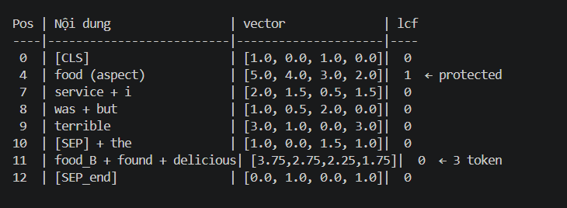
---
6 — Combined: LCF-CDM + Bipartite + resize

Config "lcf_bip_resize" (run_joint_experiments.py:116):
use_lcf=True, use_cdm=True, use_tome=True,
tome_resize=True, merge_strategy="bipartite"

Dùng bipartite 2-step ở trên → 9 tokens sau merge, rồi resize về 128.

Step A: BERT → hidden

hidden: (1, 128, 4)
# 13 valid rows = toy vectors, 115 PAD rows = zeros

Step B: ToMe bipartite

_, hidden, lcf_vec, new_attn_mask = self.tome.forward_with_trace(
hidden, lcf_vec, attention_mask.float()
)
# resize=True → new_attn_mask = None

Bên trong, chạy bipartite 2 steps → 9 tokens:

x_seg (9, 4):
[0] [CLS] [1.0, 0.0, 1.0, 0.0] lcf=0
[1] i + food_B + service [3.0, 2.25,1.25,1.75] lcf=0
[2] found [2.0, 1.0, 2.0, 1.0] lcf=0
[3] the + [SEP_mid] [1.0, 0.0, 1.5, 1.0] lcf=0
[4] food (aspect) [5.0, 4.0, 3.0, 2.0] lcf=1
[5] delicious [4.0, 3.0, 2.0, 2.0] lcf=0
[6] but + was [1.0, 0.5, 2.0, 0.0] lcf=0
[7] terrible [3.0, 1.0, 0.0, 3.0] lcf=0
[8] [SEP_end] [0.0, 1.0, 0.0, 1.0] lcf=0

Resize 9 → 128 (_resize_to_length, line 412):

xd = x_seg.unsqueeze(0).transpose(1, 2) # (1, 4, 9)
xd = F.interpolate(xd, size=128, mode="linear", align_corners=False)
x_out = xd.transpose(1, 2).squeeze(0) # (128, 4)

Nội suy tuyến tính: 9 điểm → 128 điểm. Mỗi vị trí trong 128 là nội suy giữa 2 trong 9 điểm:

Mapping: position p trong [0..127] → vị trí trong [0..8]
t = p × (9-1) / (128-1) = p × 8/127

ví dụ:
p=0: t=0.000 → x[0] = x_seg[0] = [1.0, 0.0, 1.0, 0.0]
p=14: t=0.882 → x[14] = lerp(x_seg[0], x_seg[1], 0.882)
= 0.118×[1,0,1,0] + 0.882×[3,2.25,1.25,1.75]
= [2.646, 1.985, 1.220, 1.545]
p=32: t=2.016 → nằm giữa x_seg[2] và x_seg[3]
p=63: t≈3.97 → nằm gần x_seg[4] (aspect region)
p=64: t≈4.04 → nằm gần x_seg[4] (aspect region)
p=127: t=8.000 → x[127] = x_seg[8] = [0.0, 1.0, 0.0, 1.0]

lcf_vec sau resize:
lcf_seg = [0,0,0,0,1,0,0,0,0] (5 điểm)
Sau interpolate → 128 điểm:
region p~56..71 có lcf ≈ 0.6–1.0 (vùng aspect "loang ra")
Vì t=4 tương ứng p≈64, nên lcf[64]≈1.0, các vị trí gần đó giảm dần

Step C: CDM từ lcf_vec đã resize

cdm = _compute_cdm_weights(lcf_vec, attention_mask.to(hidden.dtype), srd_threshold=5)

lcf_vec sau resize không còn binary. Code tìm: asp = nonzero(lcf_vec[0] > 0.5)

Giả sử vùng lcf > 0.5 nằm tại positions ~57–71 (15 positions):
a_start = 57, a_end = 71
center = (57+71)/2 = 64.0
half_aspect = floor((71-57+1)/2) = floor(7.5) = 7

SRD_i = max(0, |i - 64| - 7)

CDM = 1 khi SRD ≤ 5: positions với |i-64| ≤ 12, tức i ∈ [52, 76]

CDM vector (128 positions):
pos 0–51: 0 (quá xa aspect)
pos 52–76: 1 (local context window 25 tokens)
pos 77–127: 0 (quá xa aspect)

Step D: Local stream

lcf_features = hidden × cdm.unsqueeze(-1) # (1, 128, 4)

# hidden[52–76]: giữ nguyên
# hidden[0–51]: [0,0,0,0]
# hidden[77–127]:[0,0,0,0]

Step E: bert_SA → fusion → bert_SA_ → BertPooler → heads

lcf_features = self.bert_SA(lcf_features) # SA trên local stream
cat = torch.cat([lcf_features, hidden], dim=-1) # (1, 128, 8)
cat = self.linear2(cat) # (1, 128, 4)
cat = self.bert_SA_(cat)
pooled = self.bert_pooler(cat) # (1, 4)
# extract pos0 [CLS], Linear(4→4), tanh

Step F: Outputs

sentiment_logits = dense_sentiment(pooled) # (1, 3)
aspect_cat_logits = dense_aspect_cat(pooled) # (1, num_cat)

# → argmax(sentiment_logits) = 0 → "positive"
# → argmax(aspect_cat_logits) = idx("FOOD")

Tổng hợp
---
ToMe KHÔNG tạo ra feature mới. Nó chỉ giảm số token bằng cách average các token tương đồng:

Trước ToMe: hidden[b] = [v_CLS, v_i, v_found, v_the, v_food, v_delicious, ..., v_SEP]
(13 rows × H)

Sau ToMe: hidden[b] = [v_CLS, avg(v_i,v_food_B,v_service), v_found, ..., v_SEP]
(9 rows × H) ← 4 token đã bị merge

Output của ToMe được dùng ngay cho LCF ở bước tiếp theo — không đi qua layer nào khác.

---
Input: hidden (B, L, H) (từ ToMe hoặc thẳng từ BERT)

Output: lcf_features (B, L, H) — local stream

cdm = _compute_cdm_weights(lcf_vec, ...) # (B, L) — binary mask {0,1}
lcf_features = hidden * cdm.unsqueeze(-1) # (B, L, H) — element-wise scale

Về cơ bản, LCF tạo ra một bản copy của hidden nhưng đã xóa các token xa aspect:

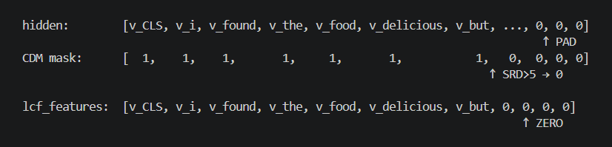
hidden vẫn được giữ nguyên — đây là global stream. lcf_features là local stream.

---
Từ 2 output này đến 2 label — 4 bước còn lại
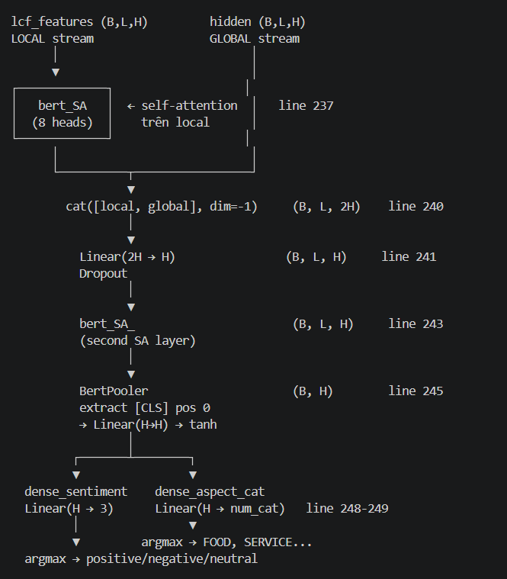
CLS ở BertPooler là từ cả_feature không phải Bert gốc
